SunRISE Dual Dipole Antenna Installation Guide August 2023
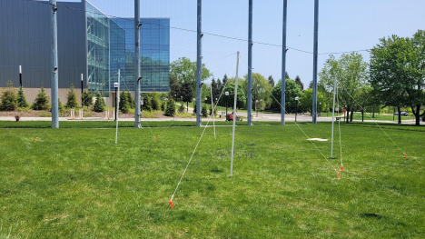
Contributors: Tremba, D.¹; Akhavan-Tafti, M.¹; Soni, S. L.¹; Higgins, C.²; Fung, S.³ ¹ Department of Climate and Space Sciences and Engineering (CLaSP), University of Michigan, Ann Arbor, MI;
² Middle Tennessee State University, Murfreesboro, TN;
³ NASA Goddard Space Flight Center, Greenbelt, MD
1
Materials
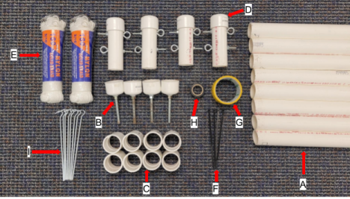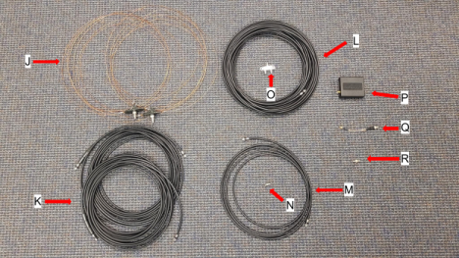A. 8 - 1.52 m (5 ft) PVC pipes
B. 4 - mast end caps (pre-assembled; a PVC cap with a bolt stuck through it) C. 8 - PVC Couplings
D. 4 - Mast Tops (pre-assembled; a short length of PVC pipe with eye bolts sticking through it)
2
E. 2 - 30.48 m (100 ft) Coils of Nylon Rope
F. 4 - 20.3 cm (8 in) Zip Ties
G. 1 - Roll of Duct Tape (optional)
H. 1 - Roll of Electrical Tape or Coaxial Sealing Tape (optional)
I. 8 - Ground Stakes
J. 2 - 7.10 m (23 ft 3 in) Dipoles (bare copper wire connected to a black insulator and coaxial cable socket in the center)
K. 2 - 12.53 m (41 ft 1.25 in) Coils of Coaxial Cable
L. 1 - 25.06 m (82 ft 2.5 in) Coil of Coaxial Cable
M. 1 - Phasing Cable - 4.70 m (15 ft 5 in) Coil of Coaxial Cable
N. 1 - Female-Female Coaxial Adapter
O. 1 - Power Combiner (small rectangular box with 3 coaxial cable sockets) P. 1 - SDR Receiver (black rectangular box)
Q. 1 - SMA to BNC Adapter Cable
R. 1 - BNC to Female Adapter
Tools Needed
● Tape Measure (8+ m)
● Compass
● Utility Knife (preferred) or Scissors
● Permanent Marker
● Rubber Mallet or Rock + Wood Block (optional)
Before Getting Started
While setting up or tearing down, be aware of your surroundings to avoid inflicting or receiving injuries that could result from swinging around PVC pipes, tangled cords on the ground, etc. Exercise due caution when setting up on a roof or when dealing with electrical connections.
We recommend having at least 2, but preferably 3 or more people to set up or tear down the SunRISE GRL Antenna. Installation generally takes 2-3 hours the first time around, but it is possible to complete within half an hour or less with enough practice or more people.
While you first instinct upon receiving your antenna components might be to throw all the packaging away, we encourage you not to do so! If you are intending to frequently set up and take down your antenna, the boxes can be great for storing the antenna components (covered in Appendix A). If you have no use for the boxes, we still encourage you to recycle them and all other packaging to the best of your ability. In some cases, even film wrappings or air pillows can be recycled at a local store, but be sure to check with the store beforehand.
3
Instructions
1. Cut Nylon Rope to Appropriate Length
a. Lay down rope next to your tape measure and measure out 6 m. Have one person hold the rope where it needs to be marked while another person holds the end of the rope, keeping it taut. Mark 6 m on the rope with a permanent marker so you'll be able to cut it accurately.
b. (Optional): If duct tape is available, it would be helpful to wrap it tightly around the spot you marked on the rope two or three times before cutting; this will help prevent fraying at the ends and make knot tying easier (be sure to keep track of where you marked so that you know where to cut when it’s covered by tape).
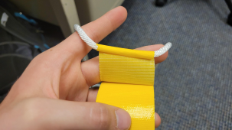
Figure 1: Step 1b
c. Next, use a utility knife to cut through the nylon rope at the spot you marked. If a utility knife isn’t available, use the sharpest pair of scissors available. When cutting, be sure that you are cutting through the middle of the tape, not around it.
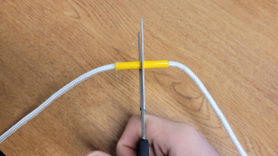
Figure 2: Step 1c
4
If you skipped step b, try to keep tension on the rope while cutting in order to prevent fraying. Repeat these steps to cut 4 lengths of rope from one 30.48 m coil and 4 from the other, making for a total of eight 6 m guy lines.
2. Assemble Masts
a. Insert one end of a 1.52 m PVC pipe into a PVC coupling, then insert another 1.52 m pipe into the other side of the coupling and push it in firmly.
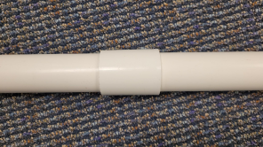
Figure 3: Step 2a
b. Attach a second coupling to the top end of the mast (this is arbitrary; either side will work) and insert the mast top into the coupling.
Figure 4: Step 2b
Be sure that there aren’t any gaps between components of the mast; push all the pieces together until they can’t move any further. If you’re having trouble with this, try forcing the top of the mast against the ground until all the pieces are securely in place. When completed, the masts should resemble the image below.
c. Repeat the above steps for each mast, making for a total of four masts. 5
Figure 5: Step 2c
3. Attach Guy Lines to Masts
a. It is imperative to note that the guy lines should always be attached to the lower eyebolt–the upper eyebolt is reserved for the dipole to attach to. Two guy lines will be attached to the lower eyebolt, as shown below.
Figure 6: Step 3a
b. At this point, it will be necessary to learn how to tie a double overhand loop in order to attach the guy lines to their masts. If you have trouble following the directions that follow, feel free to view the video linked here:
tinyurl.com/SunRISEGRLInstructionsStep3 and in the QR code below. 6

Figure 7: Step 3b
c. First, make a bend (often called a “bight” in knot tying) in the nylon rope, leaving about 30 centimeters of rope at the end.
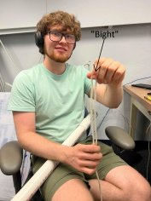
Figure 8: Step 3c
d. Next, make a loop in the rope, and then thread the bight in the rope through that loop. Thread the bight through the loop a second time and pull it tight.
7
Figure 9: Step 3d
Check to ensure that the knot resembles the images below–the rope should stay parallel to itself throughout the knot, and it should look somewhat aesthetically pleasing.
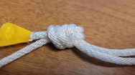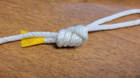Figure 10: Step 3d
Make sure that the length of rope left over on the end isn’t more than 5 cm–having too long of an end can result in length loss on the rope. The length of the loop you have now should be roughly 10 cm.
e. Now that you’re done tying the loop, you can attach the rope to the eyebolt by passing the loop through the eyebolt, then passing the other end of the rope through the loop in the rope. Pull the rope all the way through until it looks like the last image on the right.
8
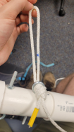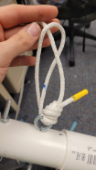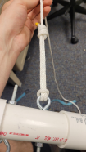
Figure 11: Step 3e
f. Repeat for all other guy lines, attaching two guy lines to each mast. 4. Tie Loops for Stakes
a. Lay the tape measure down on the ground and extend it to ~440 cm. Have another person hold the top of a mast tightly and line it up such that the end of the bottom eyebolt where the rope attaches is at the location where the tape measure reads zero. Extend the rope to 440 cm, using the tape measure as a guide.
Figure 12: Step 4a
b. Pull on the rope and keep enough tension on it such that it vibrates like a guitar string when plucked (though it probably won’t make a sound like one), then use a permanent marker to mark where 440 cm is located on the rope while keeping it tense. You can now release the tension in the rope.
9
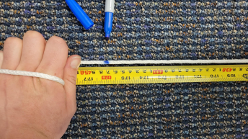Figure 13: Step 4b
c. Make a bight in the rope at the point you just marked such that the rope is doubled up, then tie a double overhand loop at least 2 cm long.
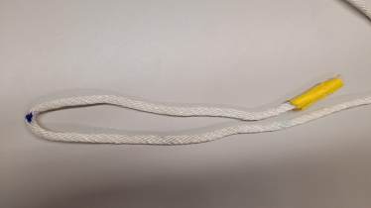Figure 14: Step 4c
10
Figure 15: Step 4c
d. Repeat for all other guy lines
5. Make Ground Measurements
a. Find a flat area with at least 12x12 meters (39.4x39.4 ft) of space oriented N-S on two opposite sides (thus E-W on the other two), free of overhead obstructions and as far as possible from tall buildings, metal fences, and other metal structures–especially power lines. An unobstructed view in the direction of the Sun and/or Jupiter is desirable–to have a good view all year round, this would be in the direction of the equator relative to your latitude. When you start taking measurements, make sure that you have enough room for the stakes to go into the ground–these will be positioned at a 3.05 m radius relative to each mast.
b. Use a compass and tape measure to take measurements in order to establish masts as shown in the diagram below (note that you will not be installing any of these yet, just marking where they go). It is imperative that the antenna structure maintains its orientation with respect to the cardinal directions.
11
Figure 16: Step 5b
As you measure out where each mast is meant to go, insert the mast end cap into the ground to mark the spot accordingly; keep it as vertical as possible. If necessary, you can use a rock or rubber mallet to lightly pound the piece into the ground; if you use a rock it would be ideal to cover the PVC cap with a wood block so that it doesn’t get damaged while driving it into the ground. You do not need to mark where the stakes will go like you did with the masts–the dimensions given above for the stakes are an approximation and do not need to be exact.
12
Figure 17: Step 5b
6. Preparations for Antenna Installation
a. Lay out all four masts with the bottom of each mast close to the location where it’ll be inserted later.
b. Before connecting the dipoles to their masts, unroll them and find the black plastic insulator at the center of each dipole. Look carefully at the black insulator and find the raised “+” symbol (this can be difficult to see; even if you’re absolutely certain it’s not there, keep looking and you’ll find it). When you connect the dipoles to their masts, make sure that this symbol is on the west side of both dipoles–this is absolutely crucial.
Figure 18: Step 6b
13
c. Take the end of one dipole and attach it to the top eyebolt of a mast with a zip tie, but be sure not to make it so tight that the eyebolt comes in contact with the dipole–you should be able to fit at least two or three fingers between the dipole and the eyebolt. The zip tie is meant to serve as an insulator between the two, and having them come into contact will effectively lengthen the antenna (this is bad). Attach the other end of the dipole to its mast along the E-W axis.
Figure 19: Step 6c
d. Find the coaxial socket located on the black insulator at the center of the dipole. Before connecting, make sure that the coaxial cables are untangled. Connect one 12.53 m coaxial cable to the dipole, being sure that you connect the end of the cable with ferrite toroids attached to it (these are small black cylinders roughly 3 cm long).
Figure 20: Step 6d
14
If you’re not sure how to connect a coaxial cable, you can visit tinyurl.com/SunRISEGRLInstructionsCoax, view the QR below, or read the directions that follow.
Figure 21: Step 6d
First look closely at the socket. You’ll see that the socket is threaded, and the cable will have a nut on it that needs to be screwed clockwise onto the threads of the socket. Note also that it can be difficult to screw the nut on if the cable isn’t aligned perfectly with the socket; if it gets stuck, try moving the cable around until you are able to freely turn the nut.
Figure 22: Step 6d
15
When working with coaxial cables, try not to let the ends of the cables come in contact with the ground, otherwise they could be clogged with dust, dirt, etc. If this happens, however, it’s fairly easy to dislodge debris by blowing on the connector.
e. (Optional): If available, it could be helpful to cover the coaxial connections using electrical tape or coaxial sealing tape–especially if the antenna will be exposed to moisture during its 2-year deployment. If you decide that it’s necessary to do this, we recommend wrapping all coaxial connections (anywhere that a cable screws onto a socket) with the tape, not just the ones that are connected to the dipoles. When done wrapping the connections, cut the tape using a utility knife or scissors.
Figure 23: Step 6e
f. Repeat the above steps for the remaining set of masts if you haven’t done so already
7. Antenna Installation
a. Hold one of the masts vertical and insert the foot of the mast into the end cap embedded in the ground. You will probably need to use your bodyweight in order to get the mast to go all the way into the cap.
16
Figure 24: Step 7a
b. While the other person is holding up the mast, loop the ends of the guy lines around their stakes and insert the stakes halfway into the ground at a 45° angle with respect to the mast, angled away from the mast.
Figure 25: Step 7b
While inserting the stakes, try to keep as much tension on the guy lines as possible, as these will provide most of the structural support for the antenna. Whoever is holding up the mast will likely need to fight against you to keep the
17
mast vertical; this is perfectly fine. Try to have the guy lines and dipoles form ~120° angles relative to each other, but don’t spend any time trying to make this perfect; it doesn’t need to be exact. If you’re having trouble getting the stakes to go into the ground, try hitting them with a rubber mallet or a rock.
c. Before erecting the second mast, have your second person continue holding the first mast up. While they’re holding up the first mast, you should put the second mast up and then have them come over and insert the stakes in the ground as described in steps 7a and 7b. The antenna dipole should be fairly taut and parallel to the ground after raising both masts, however some sagging is normal. If it is not taut, try moving the stakes further from the masts to make the guy lines tighter. If it still is not taut, move one mast as needed along the E-W line, reinsert it in the ground, and reinsert the stakes as described in step 6g.
d. You may have noticed that some of the masts aren’t perfectly straight; if so, you may adjust the positioning of the stakes to get the masts closer to vertical. Note, however, that the masts will always flex to some extent, and perfection is not required.
e. Repeat the above steps for the remaining set of masts if you haven’t done so already.
Figure 26: Step 7e
8. Coaxial Wiring
a. VARIES DEPENDING ON LATITUDE: If you are located at a latitude greater than ± 30° from the equator, you must complete this step. If you are located within ± 30° from the equator, you must skip this step. Now that both coaxial cables are connected to their dipoles, you need to connect a phasing cable to help steer the antenna beam to the correct area of the sky for observing. Attach the 4.7 m phasing cable to the 12.53 m coaxial cable connected to the dipole that is closer to the equator relative to the other (the south dipole if in the Northern
18
Hemisphere; the north dipole if in the Southern Hemisphere). To help with this, a female to female coaxial adapter is included (this is the adapter that’s threaded on both ends)–simply screw both the 12.53 m cable and the phasing cable onto it. Note that even though the two ends of the adapter are different lengths, it doesn’t make a difference which end each cable is connected to. Remember to wrap the connection with tape if you completed step 6e.
Figure 27: Step 8a
b. Connect the two 12.53 m coaxial cables (one of which will now include the phasing cable if you completed step 8a) to the two sockets of the power combiner that are on the same side as each other. Note that it doesn’t make a difference which socket these two cables are connected to, however, you must make sure that the cables coming from the dipoles are both connected on the same side.
Figure 28: Step 8b
19
c. Note: steps 8c - 8e are also outlined in the Software Setup and Data Collection Manual. You do not need to repeat them. Connect the 25.06 m cable to the remaining socket of the power combiner (this is the one that’s all by itself). Connect the other end of the 25.06 m cable to the BNC to female adapter (this is the adapter that’s threaded on one side only). Once again, remember to wrap all the connections with tape if you completed step 6e.
Figure 29: Step 8c
d. Connect the BNC to female adapter to the SMA to BNC cable. The BNC connection can be a bit tricky to figure out–you’ll notice that there is a small
metal protrusion on either side of the BNC end of the adapter, and on the BNC end of the cable there is a curved metal track for the pins to slide through. Line up the pins with the track, force the adapter into the socket, and twist the adapter until the pins line up with the end of the track. The adapter should stay in place when released.
20
Figure 30: Step 8d
e. Connect the SMA to BNC cable to the SDR receiver–this is done through a small gold connector that screws on the same way as previous coaxial connections. Figure 31: Step 8e
Congratulations! You just built a dual dipole antenna capable of collecting data! You are now ready to move on to the steps outlined in the Software Setup and Data Collection Manual.
21
Appendix A: Disassembly and Storage
1. Remove Stakes and Masts
a. Choose a mast to remove first. Firmly hold the mast upright in its initial position, and have a second person remove the stakes attached to the guy lines of the mast. Pull the mast out of the ground, and remove the mast end cap from the ground if it detached; lay the mast down on its side.
Figure 32: Step 1a
b. Repeat step 1a for the mast attached to the opposite side of the dipole relative to the first mast you removed.
c. Repeat steps 1a and 1b for the second set of masts.
2. Disconnect Coaxial Cables
a. Disconnect all coaxial cable connections except:
i. The female to female adapter connected between the phasing cable and one of the 12.53 m cables. There really isn’t any point in disconnecting it from the phasing cable.
Figure 33: Step 2a
22
ii. The female connection on the BNC to female adapter. You should still disconnect the BNC end, but the adapter is very small and extremely easy to lose so it’s best to keep it connected to the 25.06 m cable to prevent this from happening.
Figure 34: Step 2a
b. Once done disconnecting the coaxial cable connections, gently coil each cable up individually for easy storage. We highly recommend tying a rope or other material around each coil so that it doesn’t become entangled with the others.
Figure 35: Step 2b
3. Disassemble Masts
a. Especially if you had to drive somewhere in order to set up, you’re going to want to at least partially disassemble the masts so that they’ll fit in your vehicle or wherever you’re storing them. Hold one of the 1.52 m pipes that make up the
mast and have a second person grab the other pipe attached via the PVC coupling and twist and pull in opposite directions until one of the pipes comes out of the coupling.
23
Figure 36: Step 3a
b. (Optional): It’s not necessary to remove the coupling from the other pipe or to remove the mast end cap from its pipe, but if you wish to do so we recommend using a rubber mallet to hit them off.
Figure 37: Step 3b
c. Hold the PVC pipe to which the mast top is attached, and have a second person twist off the mast top. Again, it doesn’t matter if the coupling stays attached or not, but you can remove it if you’d like. Do not cut the zip tie connecting the dipole to the mast top; it’s perfectly fine to leave it so that you don’t have to attach a new one next time.
24
Figure 38: Step 3c
d. Wind the guy lines around the mast top between the eyebolts and tuck in the excess rope so that they don’t become tangled later.
Figure 39: Step 3d
e. Repeat the steps above for all remaining masts.
f. Gently coil up the dipoles. Like with the coaxial cables, we recommend tying a rope around both coils individually to prevent tangling. When you pick up the coil, don’t pick it up by the wire, but by the mast tops–if you pick it up by the copper wire with the mast tops attached it could cause bending that will wear it out over time.
25
Figure 40: Step 3f
4. Storage
a. Any sizable box or bin you have available will work fine for storing everything except the 1.52 m PVC pipes; for the smaller parts like the power combiner, adapter cable, and the SDR receiver it might be wise to find a smaller bag or container to put them in.
Figure 41: Step 4a
26
b. Try to keep items that were in direct contact with the ground (the mast end caps and ground stakes) away from the electronics and cabling so that they don’t get dirty; you could put them in a separate bag, box, etc.
Figure 42: Step 4b
c. Store the components in a cool, dry place.
Appendix B: FAQs
● Q: Are there any safety precautions I should follow during installation? ○ A: Yes, safety is extremely important. While setting up or tearing down, be aware of your surroundings to avoid inflicting or receiving injuries that could result from swinging around PVC pipes, tangled cords on the ground, etc. Exercise due caution when setting up on a roof or when dealing with AC electrical connections. Most of all, you absolutely must make sure you disconnect the coaxial cable from the power combiner after each use of the antenna, as mentioned previously.
● Q: What if I don’t have a space free of power lines and/or metal structures to set up in? What if I’m in an urban area?
○ A: While an urban environment isn’t ideal due to the high density of metal structures and radio frequency interference (RFI), it is still possible to get usable data, depending on your particular case. We recommend testing for RFI in your area if you’re unsure whether the location you have chosen is suitable. In order to do this, set up the antenna to collect up to 24 hours of data; at minimum several hours near local noon (note: you will need to reference the Software Setup and Data Collection Manual). Afterwards, visit the RadioJOVE groups.io site: https://groups.io/g/radio-jove (also linked in the QR code below) and compare
27
your data with that collected by other users over the same period to see if you picked up on any of the same solar activity they did. If your solar activity data aligns with theirs, you should be able to continue observing from that spot. If not, we recommend finding an alternative location or even taking the antenna to a park or athletic field with less RFI on days when you are observing.
Figure 43: RadioJOVE groups.io site
● Q: What if I have to set up on a roof or concrete?
○ A: We recommend against setting up on a roof if possible; setting up on a roof could come with interference from air conditioning units or other electronics on the building you set up on. It is possible to get usable data from a flat roof setup, however, we are unable to provide further information tailored to this specific case. You will need to find your own solutions to ensure that the antenna can be installed properly on a hard surface.
● Q: What if I don’t have a clear view in the direction of the Sun/Jupiter? ○ A: This shouldn’t be too much of an issue if your view is blocked by trees or other non-metallic objects–even a non-electric metal pole or two in your line of sight shouldn’t be a big issue. However, if your view is blocked by buildings, power lines, or other structures containing metal, you are likely to encounter problems and we would recommend finding an alternative location.
● Q: How can I troubleshoot if I encounter issues during installation or operation? ○ A: If you encounter any issues, SunRISE GRL provides a detailed installation video guide that covers all the steps and common problems and their possible solutions. You can also reach out on the SunRISE GRL website's support forums for assistance.
28
● Q: Can the SunRISE GRL Antenna observe radio signals during cloudy weather? ○ A: Yes! Antennas can observe radio signals under various weather conditions, including partially cloudy skies, however, their performance may be compromised during significant cloud cover. It is advisable to prioritize clear-sky conditions for optimal results in radio signal detection and analysis.
Acknowledgements
SunRISE GRL was sponsored by NASA grant #AWD006989, and hosted at the Department of Climate and Space Sciences and Engineering (CLaSP), University of Michigan College of Engineering, Ann Arbor, MI. The SunRISE GRL team would like to thank 1) the RadioJOVE team for providing the initial antenna design and providing feedback throughout the development of this document (visit https://radiojove.gsfc.nasa.gov/); and 2) the students and staff at Skyline High School, Ann Arbor, MI for their support in testing the manual and providing feedback. For more information, visit the SunRISE GRL webpage:
sunrise.umich.edu
29

